Dial-Up Modem

☎️ What is a Dial-Up Modem?
# Source: Chatgpt (GPT‑5 Mini) at [12/18/2025]
A Dial-Up Modem is a device that connects a computer to the internet over a standard telephone line by dialing into an Internet Service Provider (ISP). It converts digital signals from the computer into analog audio tones, and vice versa, allowing data to travel over analog phone systems.
It was widely used in the 1990s and early 2000s before broadband (DSL, cable, fiber) became common.

🔄 How It Works
# Source: Chatgpt (GPT‑5 Mini) at [12/18/2025]
- The modem dials a phone number provided by your ISP.
- Once connected, it establishes a data session using sound-based signals.
- It modulates (sends) and demodulates (receives) data between your PC and the ISP — very slowly.
🛜 It uses the public switched telephone network (PSTN).

🖥️ Example Setup
# Source: Chatgpt (GPT‑5 Mini) at [12/18/2025]

[PC] ←(Serial/USB)→ [Dial-Up Modem] ←(RJ-11)→ [Phone Jack] ←→ [ISP]

- You hear the classic "screeching" dial-up handshake when it connects.

🔧 Key Features
# Source: Chatgpt (GPT‑5 Mini) at [12/18/2025]


Feature | Description
Connection Speed | Up to 56 Kbps (kilobits per second)
Uses Phone Line | Shares line with your telephone (can't use both at once)
Connection Time | Takes ~10–30 seconds to dial in
Authentication | Requires username and password
Protocols Used | PPP (Point-to-Point Protocol), SLIP

🆚 Dial-Up vs Modern Internet
# Source: Chatgpt (GPT‑5 Mini) at [12/18/2025]
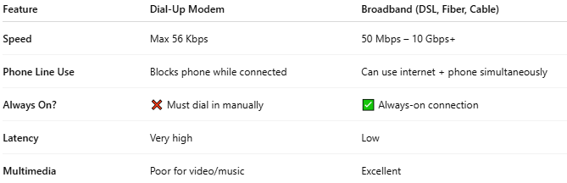

Feature | Dial-Up Modem | Broadband (DSL, Fiber, Cable)
Speed | Max 56 Kbps | 50 Mbps – 10 Gbps+
Phone Line Use | Blocks phone while connected | Can use internet + phone simultaneously
Always On? | ❌ Must dial in manually | ✅ Always-on connection
Latency | Very high | Low
Multimedia | Poor for video/music | Excellent

✅ Pros (in its time)
# Source: Chatgpt (GPT‑5 Mini) at [12/18/2025]
- Simple setup
- Worked anywhere with a phone line
- Cheap internet access

❌ Cons
# Source: Chatgpt (GPT‑5 Mini) at [12/18/2025]
- ❌ Very slow (unsuitable for modern websites)
- ❌ No multitasking (can't use phone while online)
- ❌ Frequent disconnects and busy signals
- ❌ Obsolete today — almost no modern services support it

📦 Fun Fact
# Source: Chatgpt (GPT‑5 Mini) at [12/18/2025]
- Dial-up modems were built into many older computers or connected via serial or USB ports.
- The maximum practical speed was 56 Kbps due to telephone network limits.

